Chapter 11, Solution 23.

Using Fig. 11.54, design a problem to help other students to better understand how to find the rms value of a waveshape.

Although there are many ways to work this problem, this is an example based on the same kind of problem asked in the third edition.

Problem

Determine the rms value of the voltage shown in Fig. 11.54.

v(t) (V)

10

0 1 2 3 4 t (s)

Figure 11.54 For Prob. 11.23.

Solution

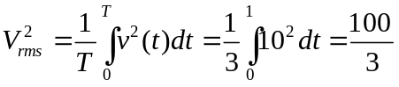

V_{rms} = 5.7735 V

